Circular Closed Shapes
# Source: AI Source: Provided by: [Data Path: Persons Table -> ID Column: 1, Name_En Column: Motasem Essam] -> From: [ChatGPT] on [7/25/2026]
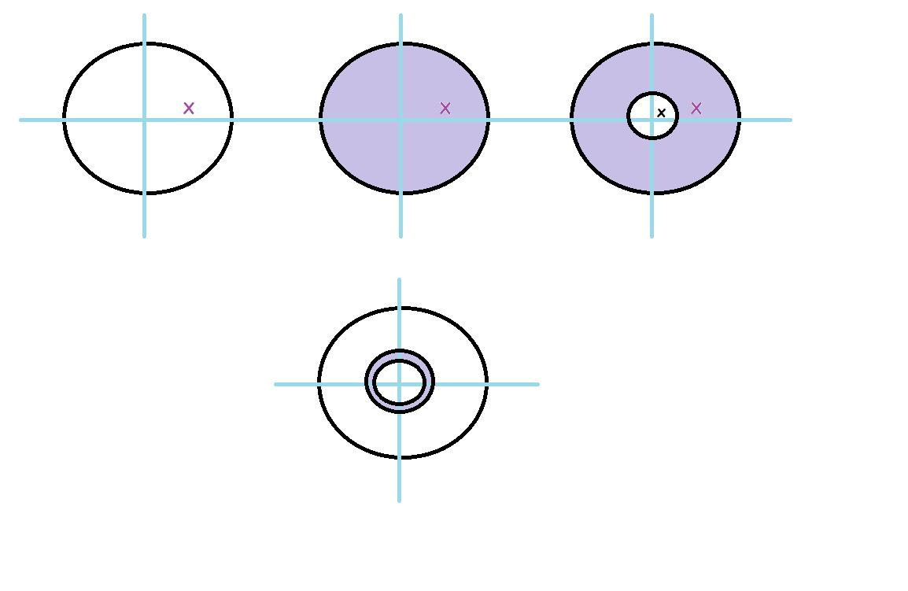
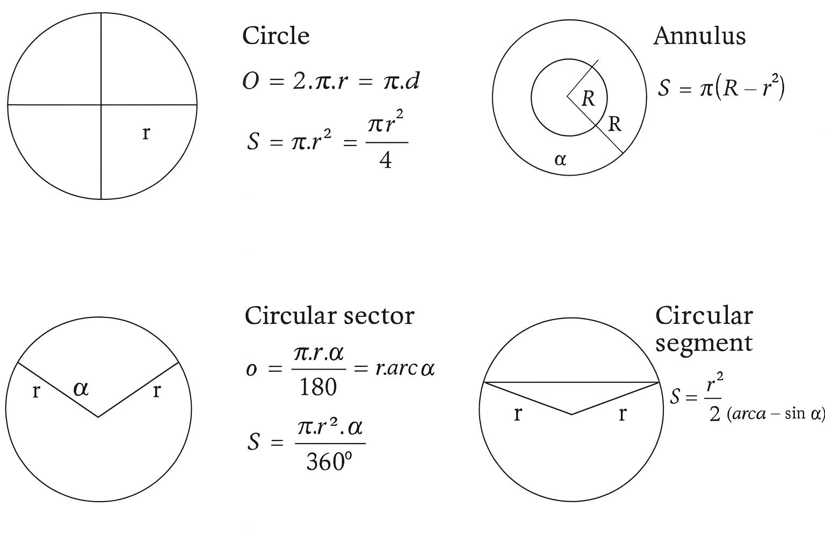
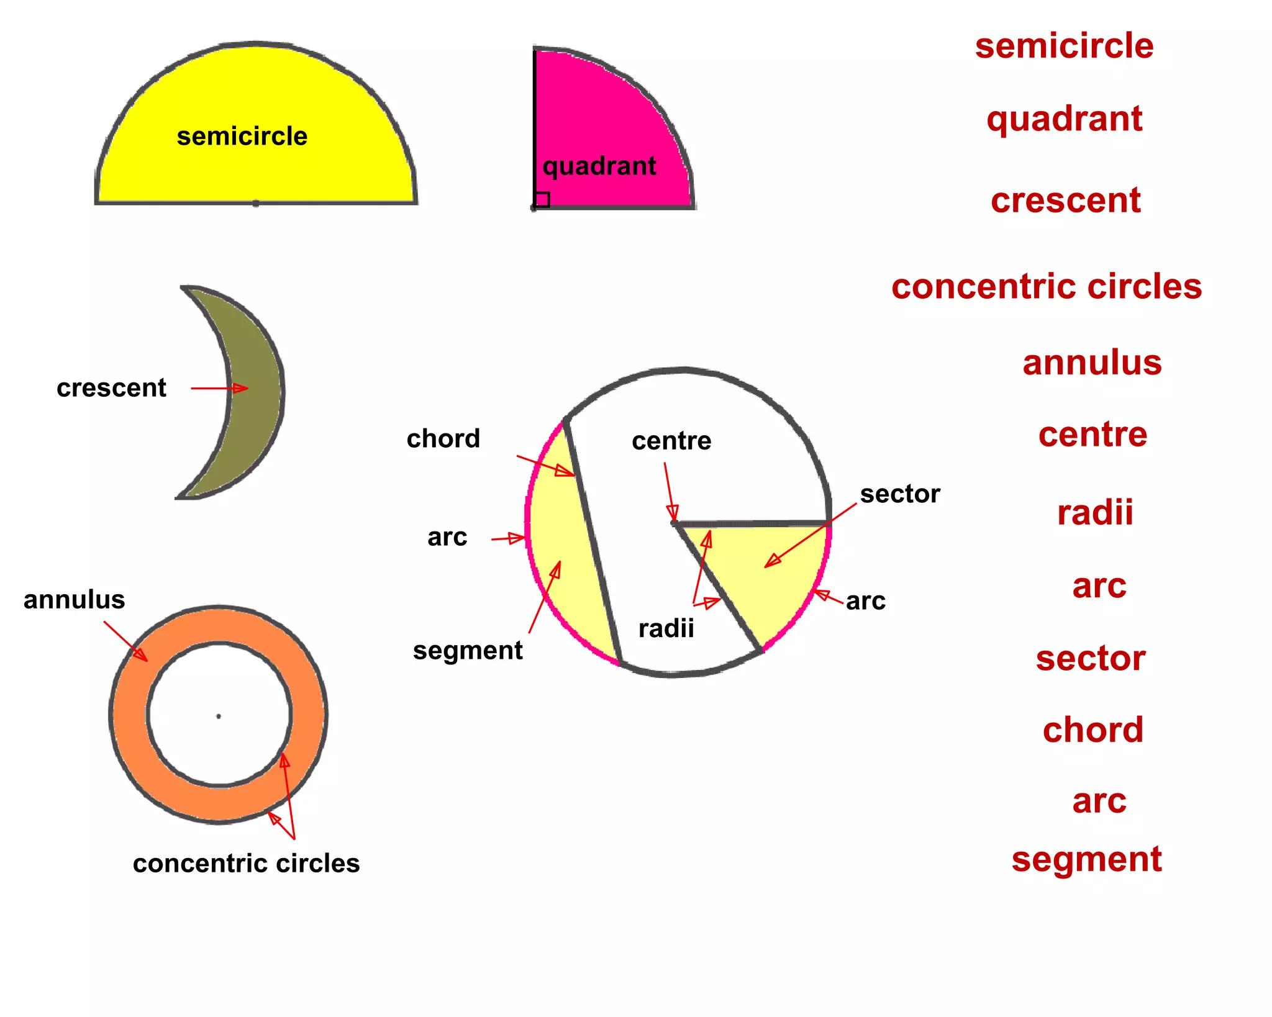
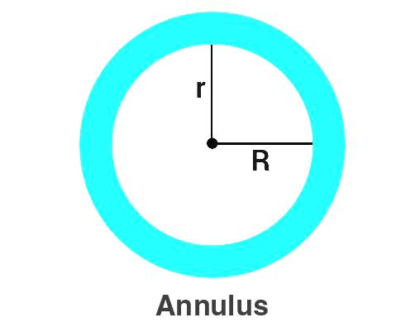

Definition
# Source: AI Source: Provided by: [Data Path: Persons Table -> ID Column: 1, Name_En Column: Motasem Essam] -> From: [ChatGPT] on [7/25/2026]
A Circular Closed Shape is a closed curved shape whose boundary is formed by a circle or one or more complete circular curves.
The simplest example is a circle.
$$\boxed{\text{Circular Closed Shape}=\text{Closed}+\text{Circular Boundary}}$$
A circle is defined as the set of all points in a plane that are the same distance from a fixed point called the center.
$$\boxed{{\left(x-h\right)}^{2}+{\left(y-k\right)}^{2}=r^{2}}$$
where:
- $\left(h,k\right)$ = center
- $r$ = radius

Types of Circular Closed Shapes

1. Circle
# Source: AI Source: Provided by: [Data Path: Persons Table -> ID Column: 1, Name_En Column: Motasem Essam] -> From: [ChatGPT] on [7/25/2026]
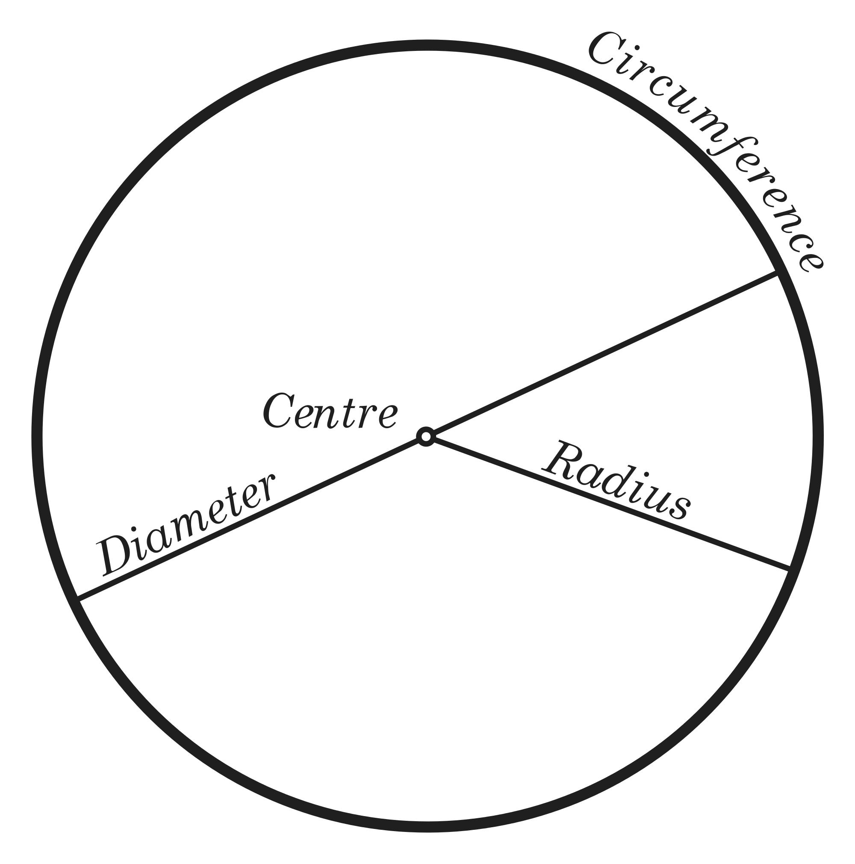
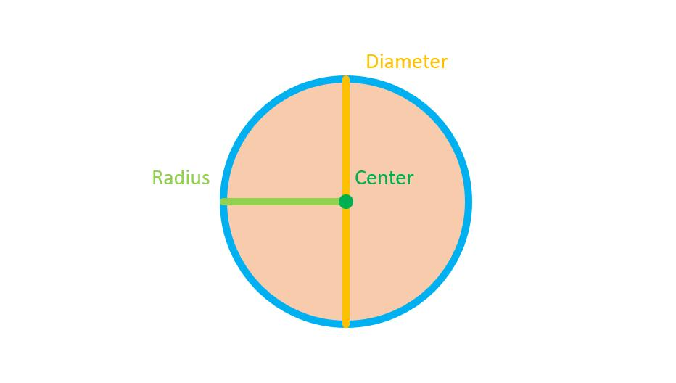
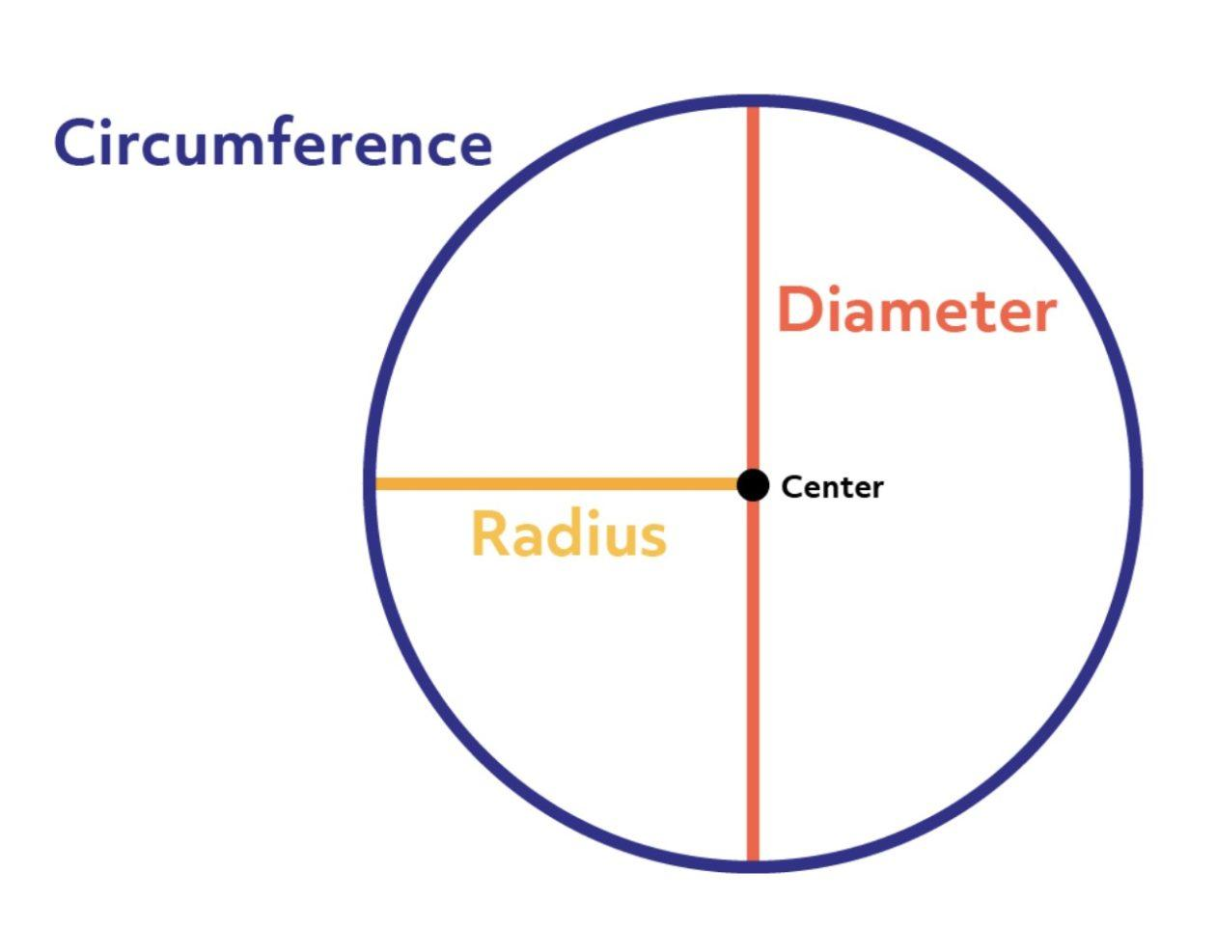
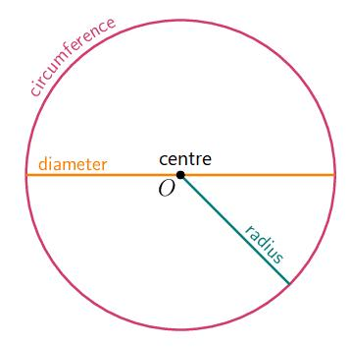
The circle is the fundamental circular closed shape.
It has:
- One continuous curved boundary.
- One center.
- A constant radius.
- No straight sides.
- No vertices.
Area
$$\boxed{A=πr^{2}}$$
Circumference
$$\boxed{C=2πr}$$

2. Circular Disk
# Source: AI Source: Provided by: [Data Path: Persons Table -> ID Column: 1, Name_En Column: Motasem Essam] -> From: [ChatGPT] on [7/25/2026]
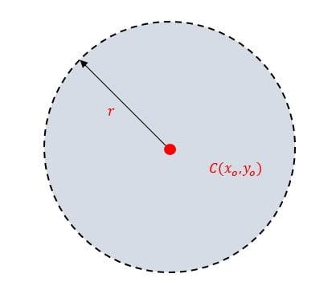
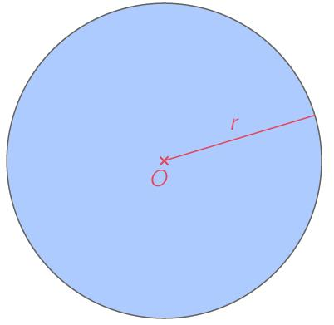
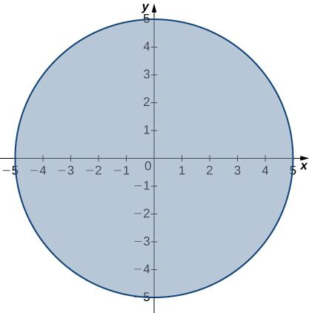
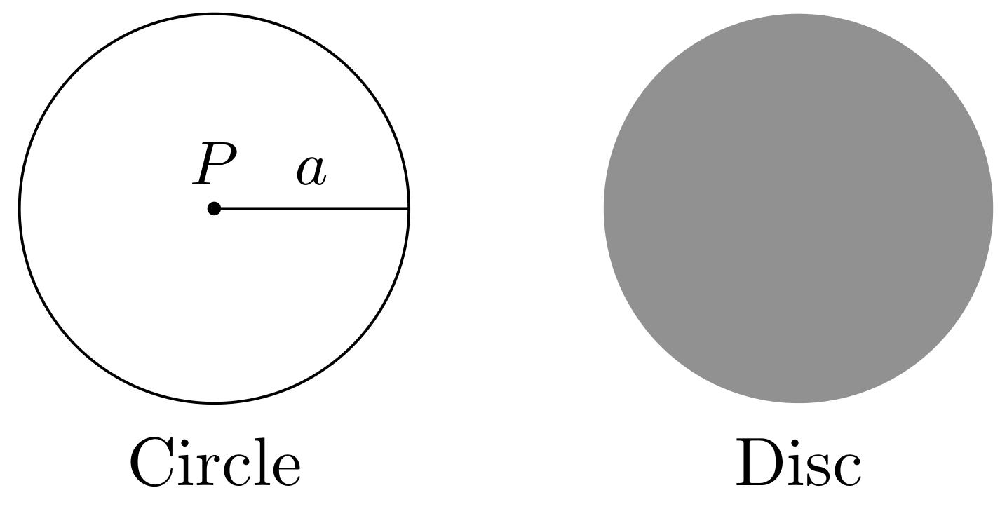
A circular disk is the entire region enclosed by a circle, including its interior.
The distinction is useful in mathematical terminology:
- Circle → boundary only.
- Disk → boundary + enclosed interior.
$$\boxed{\text{Disk}=\text{Circle Boundary}+\text{Interior}}$$

3. Annulus / Circular Ring
# Source: AI Source: Provided by: [Data Path: Persons Table -> ID Column: 1, Name_En Column: Motasem Essam] -> From: [ChatGPT] on [7/25/2026]
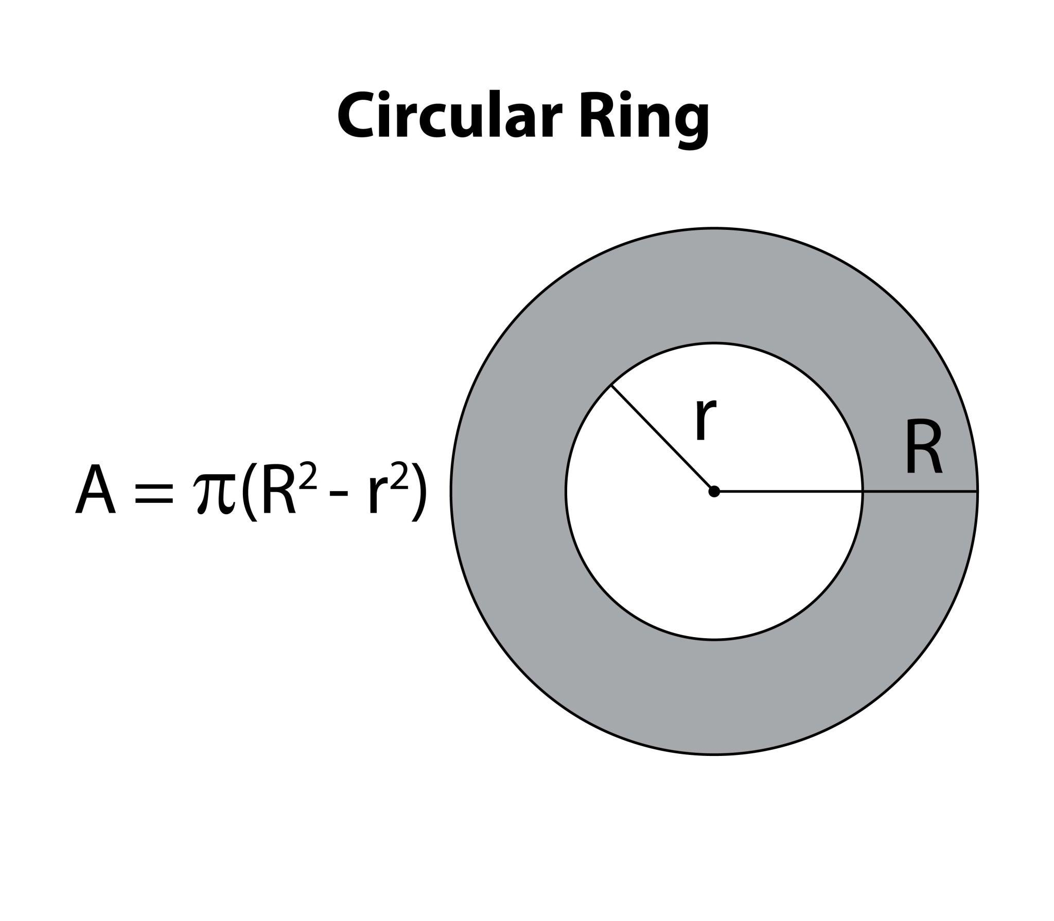
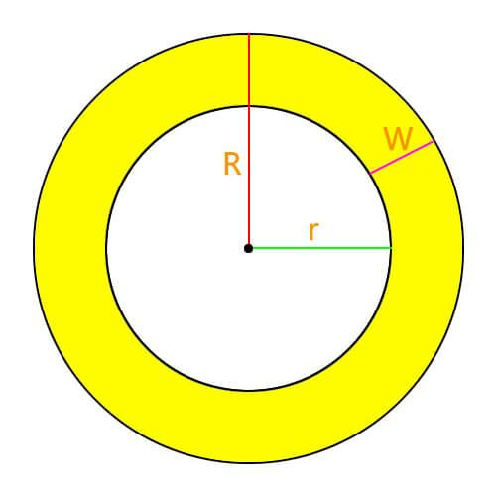
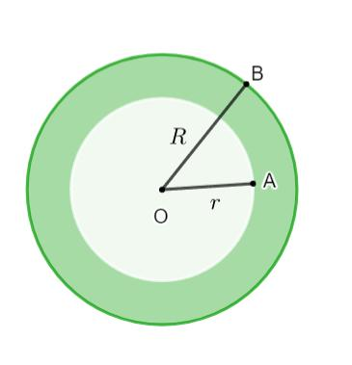
An annulus is the region between two concentric circles.
It has:
- An outer radius $R$.
- An inner radius $r$.
- Two circular closed boundaries.
Area
$$\boxed{A=π\left(R^{2}-r^{2}\right)}$$

4. Concentric Circular Region
# Source: AI Source: Provided by: [Data Path: Persons Table -> ID Column: 1, Name_En Column: Motasem Essam] -> From: [ChatGPT] on [7/25/2026]
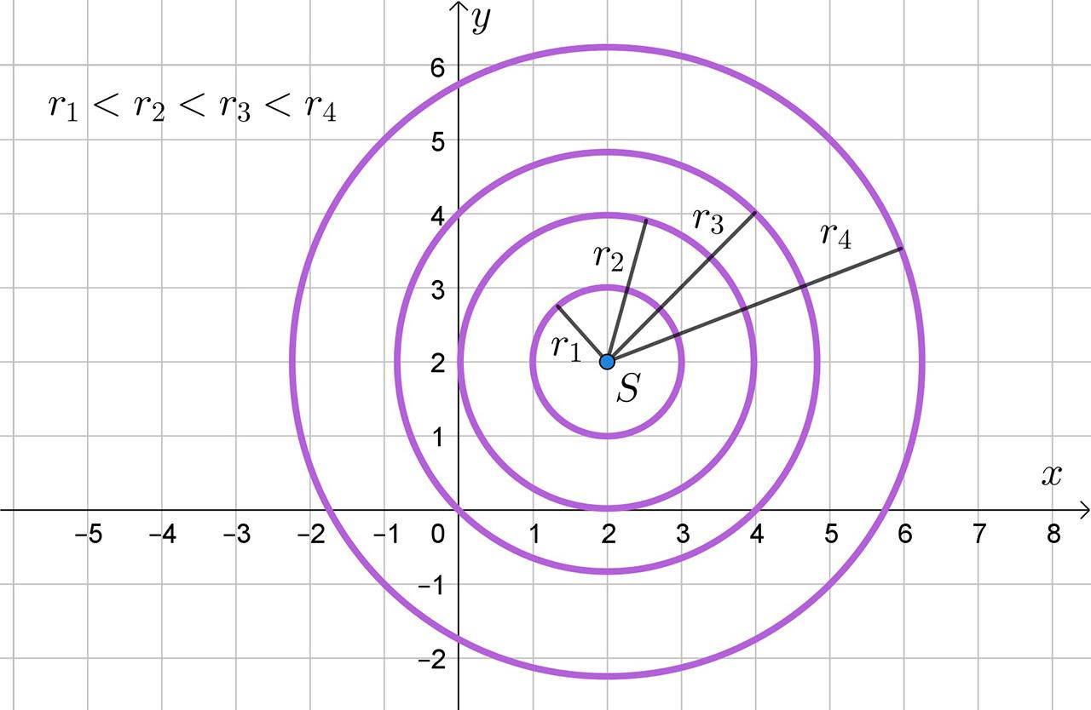
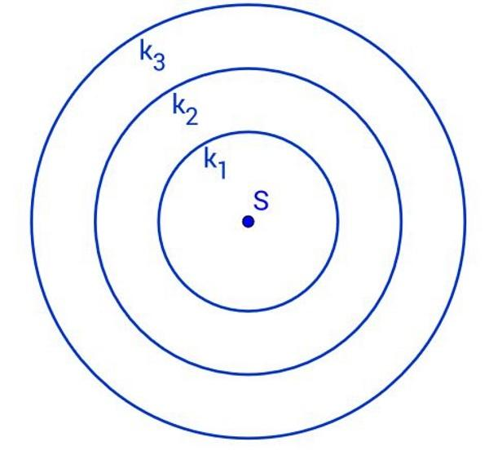
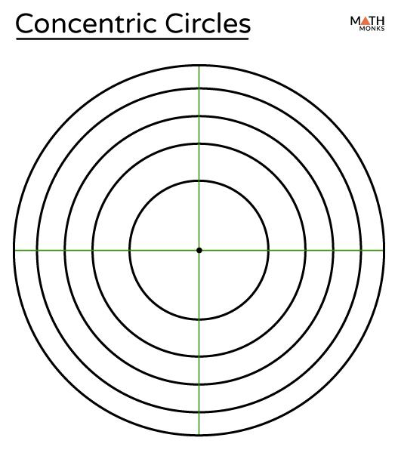
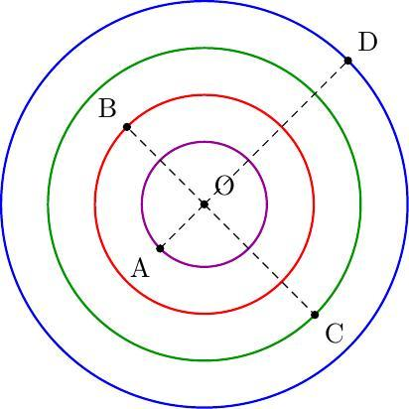
A concentric circular region consists of two or more circles sharing the same center.
$$\boxed{O_{1}=O_{2}=O_{3}=⋯}$$
The circles may divide the plane into multiple circular regions or rings.

5. Circular Sector
# Source: AI Source: Provided by: [Data Path: Persons Table -> ID Column: 1, Name_En Column: Motasem Essam] -> From: [ChatGPT] on [7/25/2026]
A sector is bounded by two radii and a circular arc.
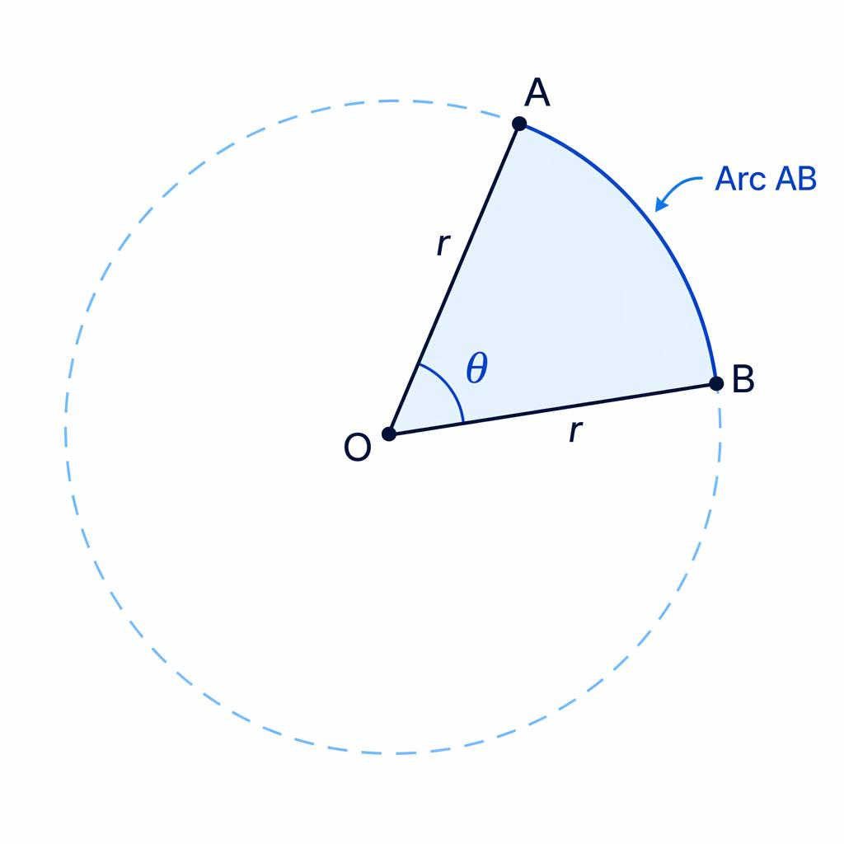
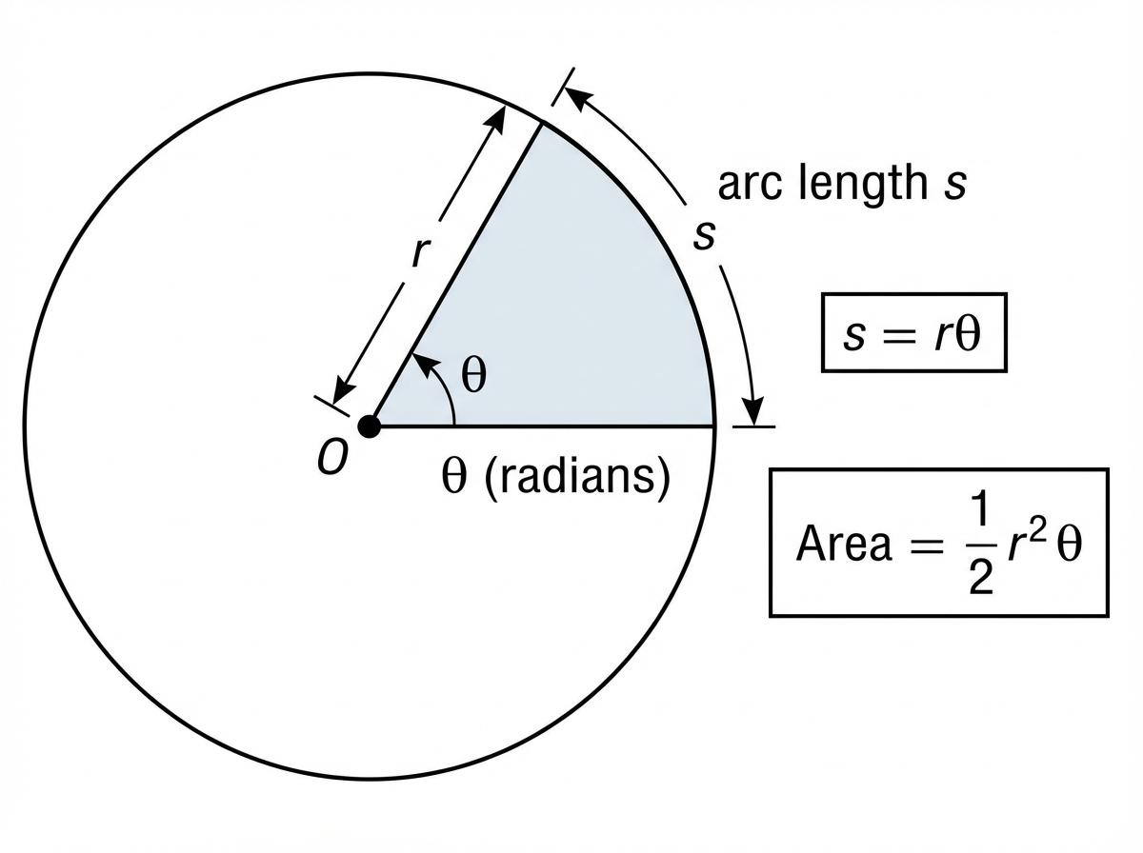
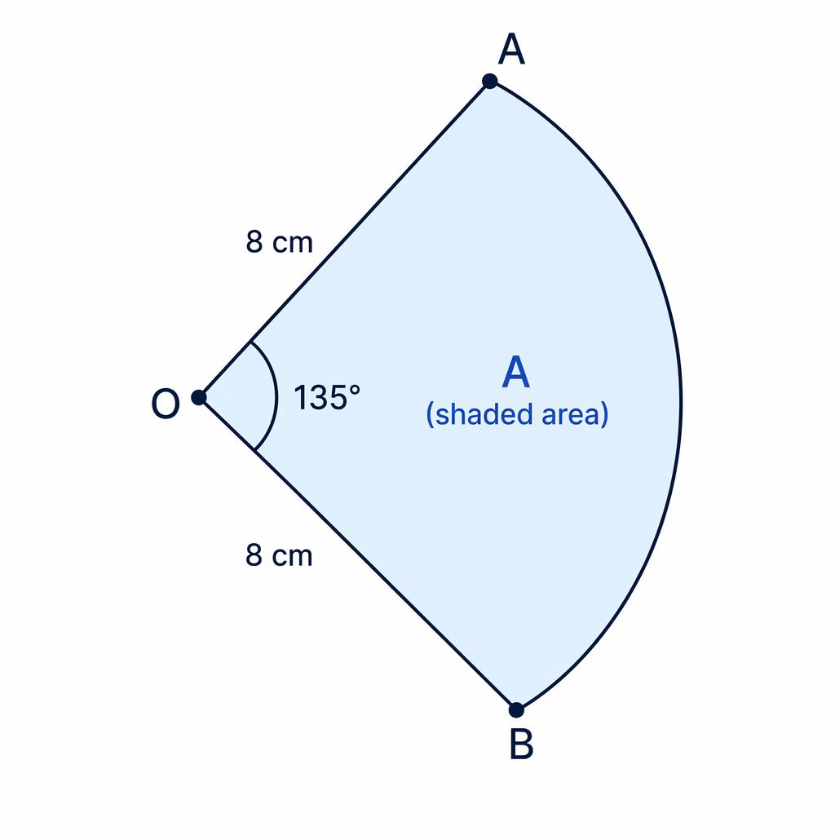
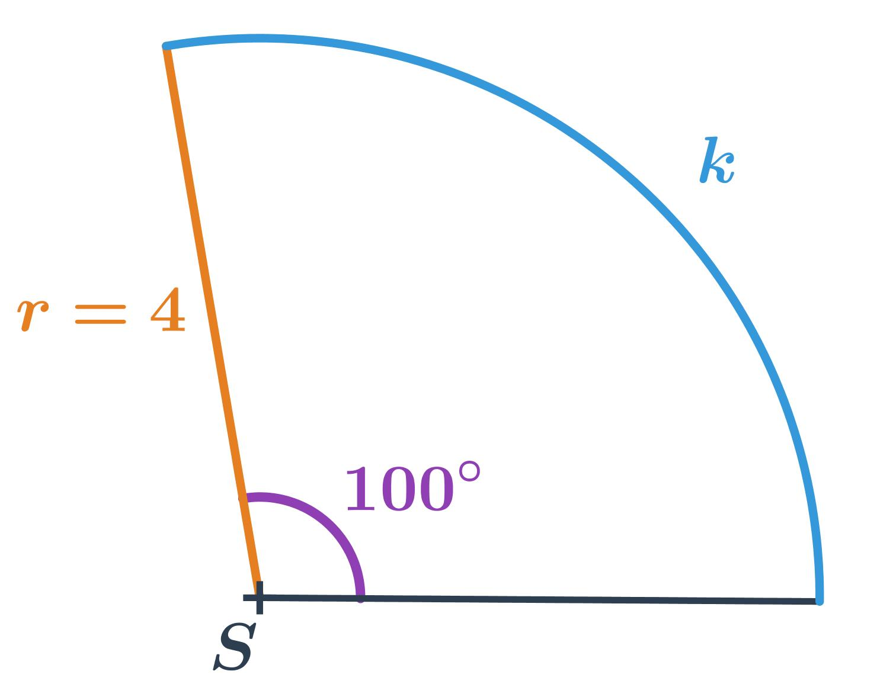
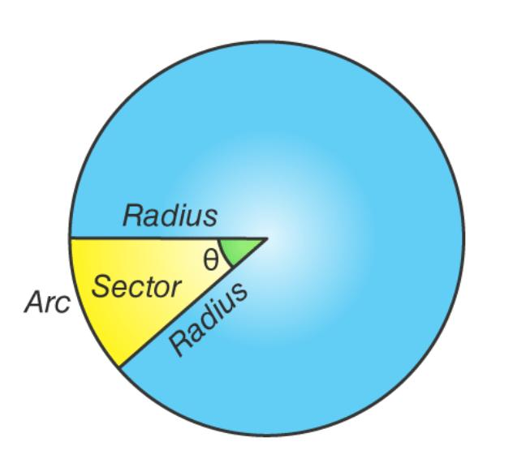
Unlike a complete circle, a sector has both straight radial boundaries and a curved circular boundary.
Therefore, for your classification system, it is more precisely a:
$$\boxed{\text{Circular–Polygonal Mixed Closed Shape}}$$
rather than a purely circular closed shape.

6. Circular Segment
# Source: AI Source: Provided by: [Data Path: Persons Table -> ID Column: 1, Name_En Column: Motasem Essam] -> From: [ChatGPT] on [7/25/2026]
A circular segment is bounded by a chord and a circular arc.
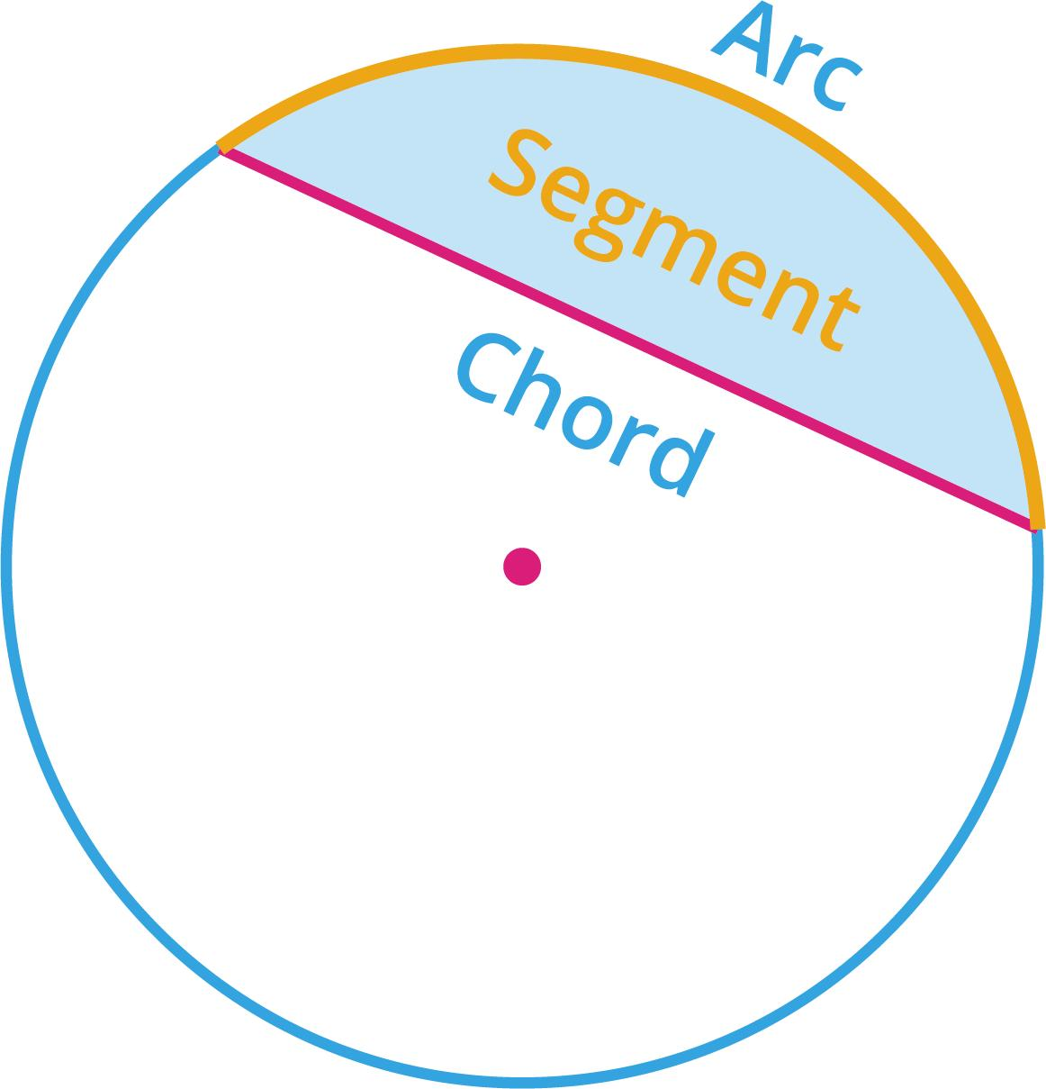
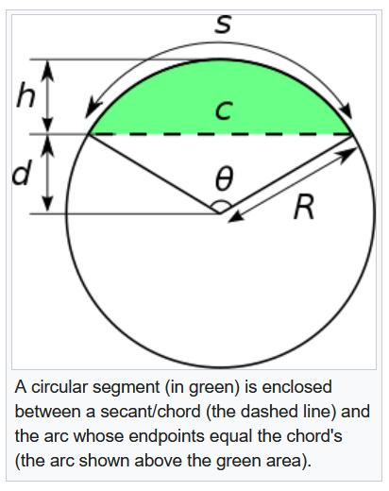
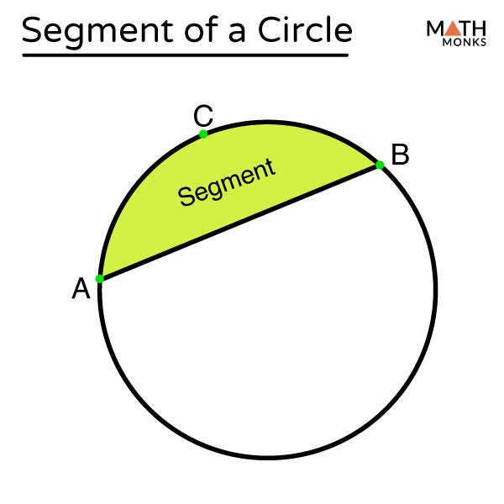
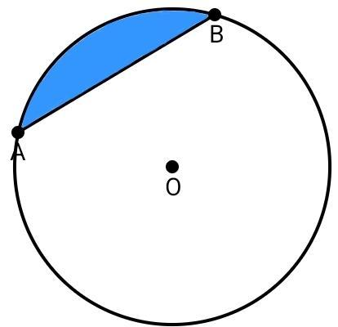
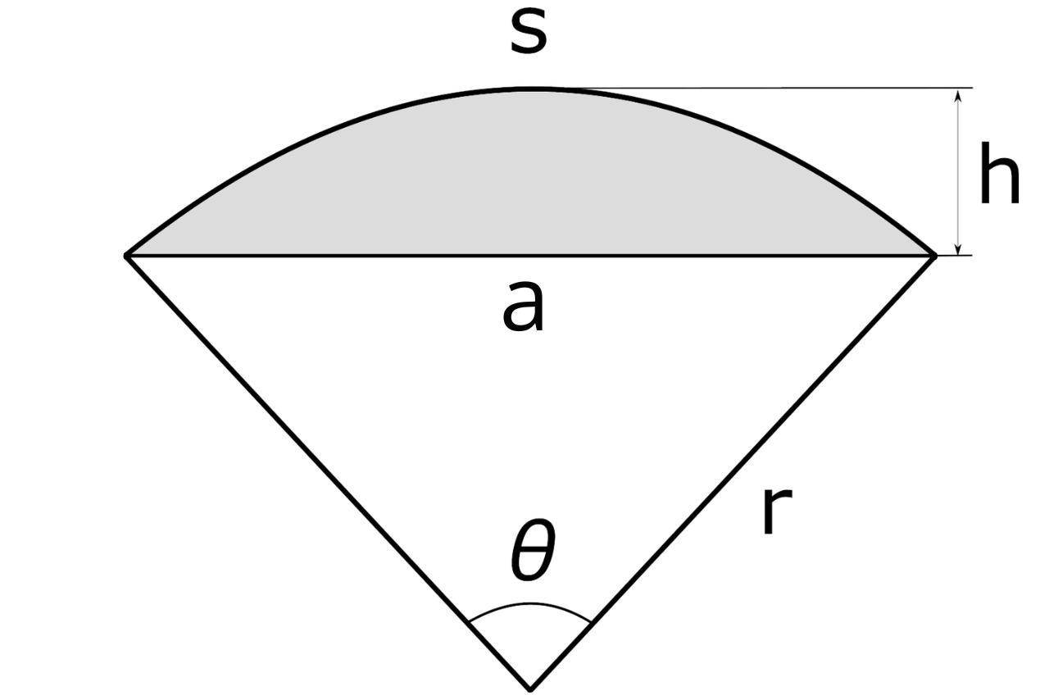
Because it contains:
- One straight chord.
- One curved circular arc.
it is also more precisely classified as a:
$$\boxed{\text{Circular–Straight Mixed Closed Shape}}$$

Classification by Symmetry
# Source: AI Source: Provided by: [Data Path: Persons Table -> ID Column: 1, Name_En Column: Motasem Essam] -> From: [ChatGPT] on [7/25/2026]
Circular closed shapes can also be classified according to symmetry.
Fully Circular
A circle has:
- Infinite lines of reflection symmetry.
- Infinite rotational symmetry.
$$\boxed{\text{Circle}=\text{Maximum Symmetry}}$$
Concentric
Multiple circles share the same center.
Non-Concentric Circular Boundaries
Multiple circular boundaries may have different centers while still forming a closed composite shape.

Circular Closed vs. Other Closed Curved Shapes
# Source: AI Source: Provided by: [Data Path: Persons Table -> ID Column: 1, Name_En Column: Motasem Essam] -> From: [ChatGPT] on [7/25/2026]
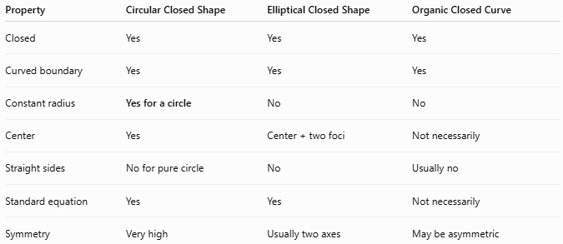
Property | Circular Closed Shape | Elliptical Closed Shape | Organic Closed Curve
Closed | Yes | Yes | Yes
Curved boundary | Yes | Yes | Yes
Constant radius | Yes for a circle | No | No
Center | Yes | Center + two foci | Not necessarily
Straight sides | No for pure circle | No | Usually no
Standard equation | Yes | Yes | Not necessarily
Symmetry | Very high | Usually two axes | May be asymmetric

Key Points
# Source: AI Source: Provided by: [Data Path: Persons Table -> ID Column: 1, Name_En Column: Motasem Essam] -> From: [ChatGPT] on [7/25/2026]
A Circular Closed Shape is characterized by complete circular boundary geometry:
$$\boxed{\text{Circular}+\text{Closed}}$$
The main examples are:
- Circle
- Circular Disk
- Annulus / Circular Ring
- Concentric Circular Regions
A sector or circular segment should instead be classified as a mixed closed shape because each contains both curved and straight boundaries.

Conclusion
# Source: AI Source: Provided by: [Data Path: Persons Table -> ID Column: 1, Name_En Column: Motasem Essam] -> From: [ChatGPT] on [7/25/2026]
Circular Closed Shapes are closed curved forms based on complete circular boundaries. The fundamental example is the circle, while related closed circular regions include disks, annuli, rings, and concentric circular regions. In a precise classification system, sectors and circular segments should be placed under Closed Mixed Shapes because they combine circular curves with straight boundaries.

